Sensitive Periods
Written by Sonia T. Kelly, M. Ed.

Dr. Montessori defined sensitive periods as inner directives acquired during a child's infantile stage while he/she is still in the process of evolving. During sensitive periods, the child experiences an irresistible attraction to one certain element of the environment, with the attraction peaking at times. Given the opportunity, the child becomes passionately involved in the element. From this intense passion, the child gains a trait or characteristic. For example, in terms of movement, the irresistible urge to kick leads to the child gaining the ability to crawl and then later to walk. Once a trait is achieved or satisfied, the urge goes away. The Montessori classroom allows for freedom of expression to respond to sensitive periods when they appear. The environment is not overwhelming and over-stimulating. It is set up in an orderly way, involving schedules and relationships. Rich, meaningful vocabulary and dialogue are provided by adults. Materials isolate senses so that the child can refine each sense, and many materials allow for the child to explore small objects since small objects attract the child to the material. Social behavior and present reflections of culture and situations are modeled in daily interaction and in grace and courtesy lessons.
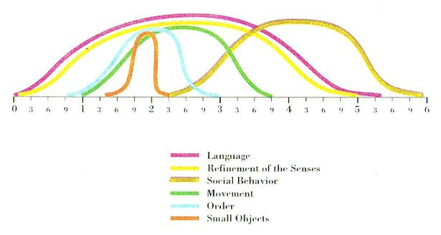
Please email Sonia Kelly at skelly@bluerivermontessori.org
or call (781) 834-4480 for more information.

